

Rosanna Cubs – Swimming night
LaTrobe Uni Swimming Pool
Tuesday 25th August, 6:30pm-8pm

Next week, we’ll be going swimming at the LaTrobe Uni Pool. Cubs will have the opportunity to go for the Level 1 or Level 2 Swimming Badge. Cubs should look in their yellow book (P136-137) before the night to choose which level they’d like to try for. They can also look at http://www.rosannacubs.org/badge/badgeSwimmer.htm
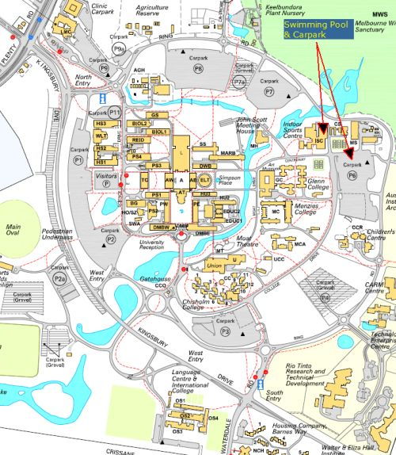
- Date: Tuesday, 25th Aug
- Time: 6:30-8pm – Note different time to
normal Cubs
- Location: Latrobe Uni Swimming Pool –
Melway 19-H6
- Bring: Togs, Towel, warm clothes to go
home in
- Note: Cubs going for Level 2 Badge need
shorts and shirt, in addition to their
togs, to swim in and remove in the
water

Don’t miss out – see you there (if you have trouble getting there, please talk to Akela (9434 7594) and we’ll see what we can arrange)!

Regards

The Leaders
Rosanna Cub Scouts

See us at http://www.rosannacubs.org

